Appendix: Product Brochure
Value Selling

Key applications: waste water discharge, WWTP & industrial waste water

CODmax plus sc Online COD Analyzer
Ordering is available on June 2nd, 2011
Note: This product bulletin is designed for sales or sales support teams. Don’t directly distribute it to our customers or potential customers.

Table of Content:

I. Overview 2
II. Applications 2
III. Specifications 2
IV. Key Features & User Implications 3
V. Comparison between CODmax plus sc, CODmax II and Previous CODmax 4
VI. When CODmax Exits the Market 6
VII. Product No. & Price 7
VIII. Frequently Asked Questions & Answers 7

Overview

CODmax plus sc is the 2nd generation chrome-based COD online monitor developed and introduced by Hach, based on the market demands on COD testing in China and the user experience and feedback on the previous CODmax.

It can be connected to Hach sc controllers to offer greater expandability. Optimized internal architecture and additional system features further improve its testing accuracy. In particular, the online data are more convenient to compare with lab titration. Meanwhile, CODmax plus sc also presents substantial improvements for easy operation and maintenance.

This product will help Hach maintain its technical leadership in online COD monitor market, and is the ideal choice of high/medium-end COD testing users.

Product Pictures
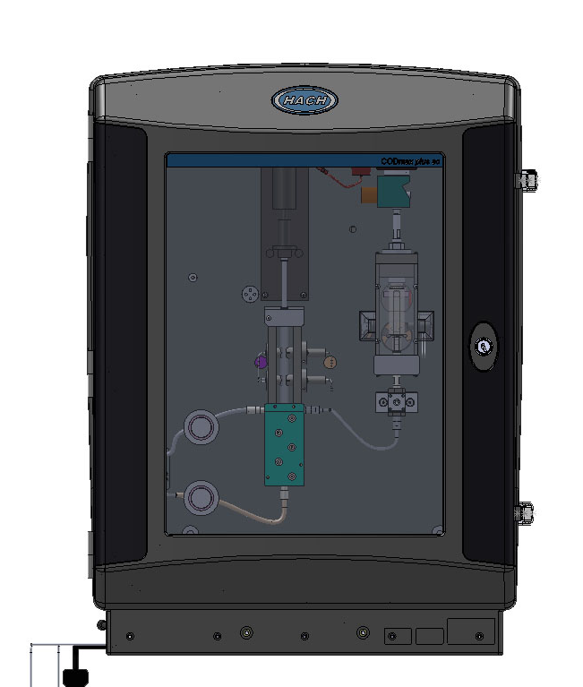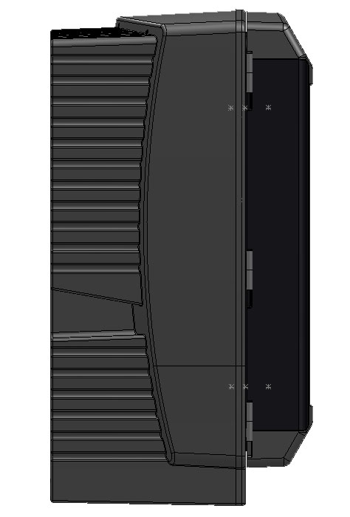

Applications
Waste water discharge monitoring: including WWTP inlet and outlet; industrial waste water discharge
Industrial process water monitoring
Surface water monitoring

It is important to recommend CODmax plus sc to large industry, new WWTP and surface water station customers.

Specifications
Measuring method: | Based on GB11914-89 Water Quality – COD Measurement – Potassium Dichromate Method
Range: | 10 ~ 5000 mg/l COD
Accuracy: | Error of indication: ±8%  Repetition: 3%  Stability of indication: ±3%
Digestion time: | 3, 5, 10, 20, 30, 40, 60, 80, 100 or 120 minutes
Interval: | Continuous measurement, 1-24 hour interval, triggered
Calibration: | Customized calibration at 5 o’clock or automated calibration.  (The interval of automated calibration can be chosen from every day to every 7 days.)
Maintenance: | Only 1 hour maintenance for each month
Reagent volume: | Each set of reagents can be used for one month under continuous measurement, digestion time of 30 minutes and calibration interval of 24 hours
Output: | Built-in 2 outputs: 0/4-20 mA, max load: 500 Ω  Built-in 2 multifunctional output relays: 24 V 1A  sc200/sc1000 controllers offer current output, relay, Modbus, Profibus and other communication functions  Access data log via SD card on SC200 or SC1000 controller
Ambient temperature: | + 5° C～+ 40° C
Power supply: | 220 VAC ± 10%/50-60 Hz
Power consumption: | Approx. 100 VA
Dimension: | Width x height x depth: 535.80mm x 711.5mm x 376mm
Mass: | Appox. 22KG (excl. reagents)
Misc: | Automated cleaning, automated logging

Key Features & User Implications
CODmax plus sc is tailored for high/medium-end online COD testing customers with higher requirements on system expandability (sc common controller), measurement accuracy and subsequent maintenance or lower price sensitivity.

CODmax plus sc provides the following features:
Can be connected to Hach sc controller | - Connected to Hach common control platform to offer greater parameter expandability  - Offer convenient data transmission thanks to the outstanding communication capabilities of Sc platform (sc 200 and sc1000 support communication protocol)  - Easier and quicker management of and access to historical data (sc line supports historical data access via SD card)  - Facilitate user operation and minimize operational error (common sc interface is simple and clear)
Higher precision and better comparison with COD lab titration | - The measurement precision of CODmax plus sc is better than other online COD testing products in the market.  - New 5-point calibration entered by the user creates more accurate calibration curve  - The correction of chloride ion interference can correct certain deviation caused by chloride ion interference in the water sample  - Customizable system configuration can tailor various testing parameters depending on application environments.
Less system maintenance & lower maintenance costs | - The internal architecture is optimized targeting at the weakness of previous CODmax. It improves the ongoing reliability of the components and reduces maintenance work and costs

CODmax plus sc provides other features as follows:
- The combination of traditional potassium dichromate oxidation and efficient digestion – the chrome-based COD measuring theory meeting the national standard in China
  - The water sample, potassium dichromate oxidation, silver sulfate and concentrated sulfuric acid are mixed and digested under high temperature and pressure. Hexavalent chrome oxidizes the organic substances in the water and is reduced to trivalent chrome, which changes its color. CODmax plus sc calculates the concentration of COD in the water sample by means of colorimetric determination.
  - The measuring theory of CODmax plus sc meets the Chrome COD Testing Method (GB/T 11941-89). The instrument completely complies with the Industry Standard on Technical Requirements of COD Water Quality Automated Monitoring Products (HJ/T 377-2007). Combined with the features of improved testing accuracy, the results are compliant with that from lab measurement and facilitate the inspection and acceptance of environmental authorities.
- Pistol pump technology and anti-corrosive piping – effectively reduce maintenance work and extend life cycle
  - As the state-of-art pistol pump is not directly in contact with water sample and reagents, it overcomes the weakness of traditional peristaltic pump.
  - The entire piping system is made of special anti-corrosive materials.
- Precise optical measurement system – more reliable measurement results and lower reagent consumption
  - When measuring the volume of water sample or reagent, the optical measurement system ensures extremely high precision, which provides more reliable measurement results and lower reagent consumption.
- Automated switch between three ranges within 10 ~ 5000 mg/L
  - Three ranges: 10 ~ 1500mg/L, 1000 ~ 3000mg/L and 1500 ~ 5000mg/L, which meet different measurement requirements of different qualities.
  - With automated range switch feature, CODmax plus sc can automatically switch to the range best for the water sample quality currently measured, without any manual intervention.
- Automated calibration – ensure accurate measurement
  - The user can set the interval of automated calibration, so that CODmax plus sc can regularly implement automated calibration and ensure measurement accuracy.
  - When the measured results exceed the upper limit of the current measurement range, CODmax plus sc will automatically switch the range, and then the instrument will run an automated calibration first, to ensure the accuracy after switch.
- Automated cleaning – reduce maintenance work
  - The user can set the interval of automated cleaning. After each interval, all pipes that the sample flows through will be cleaned by strong acid.

Comparison between CODmax plus sc, CODmax II and Previous CODmax

The list below compares the performance of newly launched CODmax plus sc and CODmax II to that of previous CODmax
 | CODmax plus sc | CODmax II & CODmax
sc platform supported | Supported (sc200 & sc1000) | sc controller not supported. Built-in controller and display module
Manual 5-point calibration supported | Supported | Not supported. Only automated calibration
Correction of chloride ion interference supported | Supported | Not supported
Customizable test parameter configuration | Supported | Not supported
Range: | 10 ~ 5000 mg/l COD | 10 ~ 5000 mg/l COD
Error of indication (potassium hydrogen phthalate test) | ±8% | ±10%
Repetition: | ≤3% | ≤5%
Indication stability (within 24 hours) | ±3% | ±5%
Digestion time: | Automated, 3, 5, 10, 20, 30, 40, 60, 80, 100 or 120 minutes | Automated, 3, 5, 10, 20, 30, 40, 60, 80, 100 or 120 minutes
Interval: | Continuous measurement, 1-24 hour interval, triggered | Continuous measurement, 1-24 hour interval, triggered
Calibration: | No calibration or automated calibration. | The interval of automated calibration can be manually set
Calibration: | Automated calibration and interval can be manually set  User can customize 5-point calibration. | The interval of automated calibration can be manually set
Reagent volume: | Each set of reagents can be used for one month under continuous measurement, digestion time of 30 minutes and calibration interval of 24 hours | Each set of reagents can be used for one month under continuous measurement, digestion time of 30 minutes and calibration interval of 24 hours
Output: | Built-in 2 outputs: 0/4-20 mA, max load: 500 Ω  Built-in 2 multifunctional output relays: 24 V 1A  sc200/sc1000 controllers offer current output, relay, Modbus, Profibus and other communication functions | 2 outputs: 0/4-20 mA, max load: 500 Ω 2 multifunctional output relays: 24 V 1A Service interface: RS 232 built-in MODBUS communication protocol
Ambient temperature: | + 5° C～+ 40° C | + 5° C～+ 40° C
Power supply: | 220 VAC ± 10%/50-60 Hz | 220 VAC ± 10%/50-60 Hz
Power consumption: | Approx. 100 VA | Approx. 100 VA
Dimension: | 535.80mm x 711.5mm x 376mm | 550 mm x 810 mm x 390 mm
Mass: | Appox. 22KG (excl. reagents) | Appox. 22KG (excl. reagents)
Misc: | Automated cleaning, automated logging | Automated cleaning, automated logging
CODmax plus sc is better than CODmax II and CODmax
CODmax plus sc is the same as CODmax II and CODmax

It shows that compared to other products, CODmax plus sc:
- Offers greater measurement precision and stability
- Supports more system functions and ensures the reliability in the comparison to lab titration
- sc controller provides better expandability,

CODmax II is consistent with CODmax in terms of performance. However, CODmax II is better than CODmax concerning improved maintenance work, reduced maintenance costs and system stability

CODmax plus sc is optimal for the customers with higher requirements on measurement precision and expecting sc platform expandability. While CODmax II is ideal for the price-sensitive customers

When CODmax Exits the Market
The ordering of CODmax plus sc and CODmax II is available since June 2nd, 2011.

The ordering of previous CODmax (product no. LPG420) will end upon today. The after-sale services of CODmax will last 5 years.

Product No. & Price
Basic instrument & accessories
Instrument & Accessories | Product No.
CODmax plus sc Online COD Automated Monitor | 9302600

Note: The above product no. of CODmax plus sc doesn’t include sc controller. Please order sc200 or sc1000 controller depending on customer needs.

The reagents of CODmax plus sc are the same as existing CODmax. See the product numbers below:
Instrument & Accessories | Product No.
CODmax reagent | LCW420

To order a whole set of online COD monitoring equipments including CODmax plus sc, the standard configuration is as follows:
Name of Instrument | Product No.
CODmax plus sc Online COD Automated Monitor | 9302600
sc200 Common Controller, with MODBUS | LXV404.99.01552
CODmax reagent | LCW420
To choose sc1000 controller, please change the product number of above sc200 to that of sc1000.

Frequently Asked Questions & Answers
- How to choose between CODmax plus sc and CODmax II?

Newly introduced by Hach, CODmax plus sc and CODmax II are all next-generation online COD monitors based on previous CODmax, which has been widely accepted by the market. Both of them offer online COD monitoring solutions to the customers, featuring accuracy, convenience and low maintenance.

However, they have different features and targets:
- CODmax plus sc is a medium/high-end online COD monitor. In addition to all the strengths of CODmax line, CODmax plus sc also provides a number of new functions, ensuring more accurate testing, more convenient operations and simpler maintenance.
    - Multi-point calibration, correction of chloride interference and customizable features substantially improve the accuracy under different applications, which further facilitates the comparison between its results and that of lab tests.
    - The connection to Hach sc200 and sc1000 also eases up its operations and maintenance. It provides more choices of data collection and transmission.
    - New design and internal structure ensure safer operations and easier maintenance
Therefore, CODmax plus sc is the ideal choice of the price-insensitive customers seeking for great accuracy and low maintenance.

- CODmax II is a medium/low-end online COD monitor. CODmax II is an upgrade of previous CODmax. It has the same accuracy as previous CODmax, yet with greater stability and lower maintenance.
CODmax II is an optimal choice of the online COD testing customers with price sensitivity.

- What is the ideal application environment of CODmax plus sc?

Sewage with the COD concentration between 10 ~ 5000 mg/L
pH value between 1 and 12
The concentration of chloride ion lower than 5g/L
The water sample with suspended solids needs preparatory treatment

- What if the application environment is not ideal?

If the water sample contains high concentration of chloride ion, it needs dilution via automated diluting device before the test.
If there is fixed deviation between the online data and the lab data due to chloride ion interference, it is possible to correct the deviation with the correction of chloride ion interference in CODmax plus sc.

- What are the applications and target customers of CODmax plus sc?

Pollution source monitoring: including city sewage inlet and outlet; industrial sewage outlet
Industrial process water monitoring
Surface water monitoring

It is essential to recommend CODmax plus sc to the following customers: Large industries, new sewage plants and surface water stations

- How does CODmax plus sc display its menu?
CODmax plus sc displays the menu on the interface of sc controller after connected to it. Click on Sensor Setup and you will see Calibrition, Configure and Maintenance. Enter Maintenance and select Signals. You will see an online information screen similar to Signal on the previous module. Back to the upper level and select Configure, you will see the setting screen the same as Setting in the previous module. Back to the upper level again and select Calibrition, you can view the result of last self-calibration or launch a new self-calibration.

- How to reconnect CODmax plus sc and Sc controller after disconnection?
CODmax plus sc will be disconnected from sc controller due to failure or shutdown. Once switched on, the connection will restore in 20 minutes. If it doesn’t restore due to some particular situations, enter the top menu and select Testmaint and then Scan devices. The instrument will relaunch a new connection.

- If any error occurs, how to restore normal operation after correcting the error?
First, eliminate the physical root cause of error. In case of insufficient sample, restore the sample supply. In case of removed safety panel, remount it. In case of water deposit in the water basin and the humidity sensor alarms, clean the basin and air-dry the surface of the sensor (dry it with paper or cloth. But it is necessary to air-dry it off the remaining moisture). Then enter State and press Reset button to reset the machine. Or enter Maintenance and select State to reset it.

- How to connect the machine to and communicate with data collector?
To connect to the data collector, insert a communication card into SC200 controller and connect the communication line of the data collector to the communication card.

- How to customize calibration?
Set the calibration as Customize calibration, enter the number of points for self-calibration and then select the calibration steps in Service page. The instrument will start to customize the calibration.

